Dear students,

danas ćete vježbati vještinu čitanja i čitanja s razumijevanjem. U nastavku slijedi tekst ‘’Help Me With My Homework’’ koji trebate najprije pročitati. Nakon što pažljivo pročitate tekst, molim vas da riješite zadatke 1, 2 i 3. Pripremila sam vam popis nepoznatih riječi i izraza koje se nalaze na kraju dokumenta, nakon 3. zadatka (UNKNOWN WORDS AND EXPRESSIONS).
Zadatke možete isprintati (ako imate tu mogućnost), riješiti na računalu ili prepisati rješenja u bilježnicu. Provjerit ćemo ih zajedno kad se vratimo na nastavu uživo.

Želim vam dobro zdravlje i nadam se da se uskoro vidimo! 😊

- Teacher Simona

1 Read the text carefully. Who is Sophie? / Pozorno pročitaj tekst.Tko je Sophie?

HELP ME WITH MY HOMEWORK!

Paula is secretly in love with Dan. Dan also fancies Paula, but he is too shy to tell her that.

One day at school…
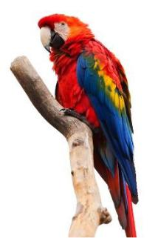

– Can you help me with my English homework, Dan? – asks Paula. Dan is very surprised, but happy.

– Of course, I can. Come to my place tomorrow and I’ll help you do it.

– When? – asks Paula.

– At half past ten. Is that OK? – says Dan.

– Fine! I usually take my dog for a walk at nine, so I’ll be there on time.

Tomorrow, at Dan’s place…

– Come on in, Paula – says Dan. – What’s the problem?

– Words, rules, spelling… everything. I’d like to have a robot to help me with my English homework.

– But English is easy… – says Dan.

– Well, I’m good at P.E., music, and art. Even at maths. But not at English. Help me with my homework, Dan. I’d be grateful to you – says Paula.

– Help me with my homework, Dan – Paula hears somebody repeating her words. She looks around, but there is nobody in the room.

– Who is that? Who’s that talking? – asks Paula.

– Sophie! – says Dan.

– Sophie? Sophie who? Is Sophie your girlfriend? – Paula is a little bit jealous.

– No, Sophie is my parrot – says Dan. – She is learning to talk.

He opens the door of his room. – This is Sophie! Isn’t she beautiful?
– Help me with my homework, Dan – repeats Sophie.

– Now I am not the only one who has problems with English – says Paula, smiling. Dan laughs.

– Don’t worry! I’ll teach you both, girls – he says.

Year 4 Reading Comprehension Help Me With My Homework

2 Read the questions (1-8) and circle the best answer (a, b or c). / U svakom zadatku (1-8) zaokruži slovo ispred točnog odgovora (a, b ili c).

1 Who has got problems with doing the English homework?

- Paula

- Dan

- Sophie

2 When are Paula and Dan going to meet? At…

- 9:00

- 9:30

- 10:30

3 Where are Paula and Dan going to meet?

- At Paula’s place

- At Dan’s place

- At school

4 Has Paula got a pet?

- Yes, she has got a parrot

- No, she hasn’t got a pet

- Yes, she has got a dog
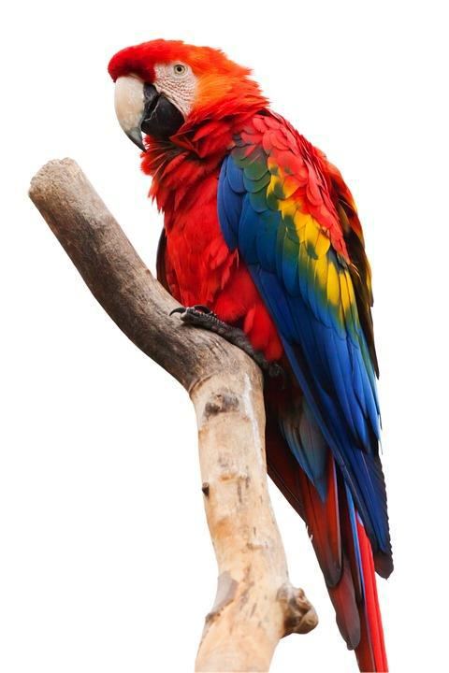

5 Paula is good at…

- English and P.E.

- maths and English

- music and art

6 Who says: ‘Help me with my homework’?

- Paula and Dan

- Dan and Sophie

- Sophie and Paula

7 Who is Sophie?

- Paula’s parrot

- Dan’s pet

- Dan’s girlfriend

8 Why is Paula a little bit jealous?

- Because Dan knows English better than she does

- Because she thinks that Sophie is Dan’s girlfriend

- Because Dan has got a pet

Year 4 Reading Comprehension Help Me With My Homework

3 Read the sentences and circle YES or NO. / Pozorno pročitaj rečenice (1-8), a potom zaokruži riječ „YES“, ako je tvrdnja točna, ili riječ „NO“, ako je tvrdnja netočna.

1 Everybody knows that Paula is in love with David. | YES | NO
2 Dan is good at English. | YES | NO
3 Dan and Paula are going to meet in the afternoon. | YES | NO
4 Dan is going to help Paula with her homework. | YES | NO
5 Paula isn’t good at English. | YES | NO
6 Paula has got a pet. | YES | NO
7 Sophie is Paula’s dog. | YES | NO
8 Sophie repeats Paula’s words. | YES | NO

HELP ME WITH MY HOMEWORK
- UNKNOWN WORDS AND EXPRESSIONS-

secretly = potajno
fancies = sviđa mu/joj se
come to my place = dođi k meni
I’d be grateful to you = bit ću ti zahvalan/zahvalna
jealous = ljubomoran/ljubomorna
laughs = smije se

